An Investigation of a Hotel’s Corporate Citizenship Message

Eun Yeon Kang
Doctoral Candidate
The Stan Richards School of Advertising & Public Relations
Moody College of Communication
The University of Texas at Austin

Do Not Cite or Distribute Without the Author’s Permission

An Investigation of a Hotel’s Corporate Citizenship Message

The term corporate citizenship, which first arose in American businesses in the 1980s (Altman & Vidaver-Cohen, 2000), identifies companies’ socioeconomic responsibilities to society (Etzioni, 1988; Wood, 1991). As strong influential members of society, corporations have actively undertaken their citizenship in the manner of corporate social responsibility (CSR) to maintain their status as a good citizen. Moreover, they also strive for communicating their efforts since they can demonstrate their corporate citizenship to the public, which results in achieving positive marketing outcomes such as favorable reputations, images, or choices (e.g., Golob, Lah, & Jancic, 2008). However, CSR communication may backfire in that they may elicit stakeholders’ skepticism towards a company (Du, Bhattacharya, & Sen, 2010). Specifically, CSR communication can lead consumers to be suspicious about the motives behind their CSR practices. Accordingly, how to say is critical in CSR communication.
Following the recent CSR trend focusing on environmental issues (e.g., Porter & Kramer, 2006), the current study aims to investigate green CSR communication in the hotel industry where pro-environmental efforts are primary CSR practices (Kirk, 1995). Given its size and revenue, the hotel industry is an important segment to study in the context of corporate citizenship. In 2013, the U.S. hotel industry generated revenues of $163 billion dollars. In detail, following the overarching research question – how do different presentations of a hotel’s green information affect consumer responses, this proposed study aims to examine the effects of message objectivity and different focuses on consumers’ CSR-oriented cognitive responses – skepticism, CSR motives, and message credibility – and marketing-oriented cognitive responses - brand image and reputations.

Literature Review

Message Objectivity
Among several aspects of message specificity, which indicates how a message is informative, detailed, factual, and has high quality of information (Alniacik & Yilmaz, 2012), message objectivity is a challenge in CSR communication (Kim & Lee, 2009). Message objectivity refers to the verifiability of information (Darley & Smith, 1993). An objective message usually offers explicit and concrete cues like fact-based data or numbers, which allows message receivers to easily and clearly understand the message. Conversely, subjective messages use broad terms so that people draw a conclusion based on their own interpretations (Darley & Smith, 1993). In other words, they tend to be unsure about their judgment and put more cognitive efforts into comprehending the exact meaning (Edell & Staelin, 1983). Consequently, they have lower credibility (Holbrook, 1978) and have high skepticism (Kim & Lee, 2009) towards a message. In this sense, consumers are more favorable to objective messages (Nelson, 1974).
When it comes to pro-environmental claims, subjective green claims are statements using vague wording like “environmentally-friendly,” “improve the environment,” or “less waste,” etc., without any follow-up detailed descriptions (Alniacik & Yilmaz, 2012). An example of a specific green message would be “We used water-efficient showers in 300 rooms to reduce water waste up to 45% last year, which was an increase by 10% over the previous year.” Such an accurate green message helps consumers to recognize that a hotel indeed made progress to become pro-environmental.
According to the positive message objectivity effect verified in the previous studies (e.g., Darley & Smith, 1993; Ogilvy, 1983), it is assumed that objectivity will also lead to positive results in a hotel’s green CSR communication. In particular, it prompts consumers to be less suspicious about a hotel’s CSR efforts and more likely to increase trust towards given information. Also, it drives them to consider a hotel’s motive as public-serving by implying that a hotel works truly for environmental benefits, and builds a favorable brand image and reputation.

H₁: Compared to consumers who receive a subjective message, those who receive a hotel’s green CSR message describing specific and objective green performances will
H_{1-a}: be less skeptical about green efforts.
H_{1-b}: perceive CSR motives as public-serving.
H_{1-c}: perceive higher message credibility.
H_{1-d}: have a more positive image of a hotel.
H_{1-e}: perceive a favorable reputation of a hotel.

Message Focus
Two main elements in CSR messages are commitments and impacts. Commitments explain what a firm does and impacts indicate the performance of a firm’s CSR practice like “reduce energy use by up to 40% by 2013” (Du et al., 2010). Between the two, impacts may have more powerful and positive effects because explaining how a company’s effort can actually improve society and people’s well-being may alleviate consumers’ skepticism (Becker-Olsen, Cudmore, & Hill, 2006). This can be because explaining how a company’s effort can bring societal improvement and actually help people in need may alleviate consumers’ skepticism and encourage their positive association to CSR practices and a corporation (Becker-Olsen et al., 2006). As consumer skepticism is an underlying cognitive mechanism to formulate their subsequent reactions (Becker-Olsen et al., 2006; Ellen, Webb, & Mohr, 2006) and consumers typically have a tendency to think that companies’ every action is primarily self-benefiting meaning that the bottom line of their belief towards a firm’s CSR motive is self-serving (Speed & Thompson, 2000; Webb & Mohr, 1998), emphasizing positive influences of their pro-social efforts on society would be a smart choice for their CSR communication to represent them as a socially responsible citizen.
The correspondent inference theory (Jones & Davis, 1965) supports such a notion. Stemming from Heider’s attribution theory (1944), Jones and Davis extended people’s reasoning process to evaluate others’ behavior. The theory proposes that people infer a target’s motive to act in a certain way by observing his/her behavior. Their conclusion corresponds to what his/her behavior implies as they interpret an action at face value. It is associated with his/her internal dispositions if his/her action is negative. For example, people may infer that a person is generous if they see he/she volunteering at a charity. Such proclivity is also called ‘correspondent bias’ since people disregard other situational factors that might drive them to take on a particular behavior (Jones & Harris, 1967). However, if they come to question the ulterior motives of his/her action, they engage in a deliberative thinking process and correct their correspondent inference, which is promptly made based upon the face value of given information (Fein, Hilton, & Miller, 1990). On the other hand, they reinforce their systematic correspondent inference when they perceive something about him/her that they were not aware in advance by observing his/her actions (Jones & Davis, 1965). Thus, if they already expect his/her action, they do not interpret it at face value, but rather link to his/her internal characteristics.
Consistent with the notion of the theory, consumers tend to infer the reasons for a hotel’s green practices at face value since such pro-social work does not directly link to a for-profit company. That is, for the hotels’ CSR communication, consumers may attribute hotels’ motives for engaging in pro-environmental efforts to environmental protection when they have an impact-focused message compared to a commitment-focused message. As an impact-focused message overtly communicates a hotel’s green behaviors with valid evidence and outcomes, it is assumed that consumers make and retain an inference solely based on the face value of what is communicated in the message. Also, they will enhance their favorable stances with an impact-focused message implying that a hotel’s green effort indeed makes a difference in the environment.

H₂: Compared to consumers who receive a commitment-focused message, those who receive an environmental impact-focused message will
H_{2-a}: be less skeptical about green efforts.
H_{2-b}: perceive CSR motives as public-serving.
H_{2-c}: perceive higher message credibility.
H_{2-d}: have a more positive image of a hotel.
H_{2-e}: perceive a favorable reputation of a hotel.

Mediating Effects of Skepticism
In addition to the effects of different CSR message framing effects on consumer responses, this study also contributes to explain how such effects are generated. Because consumers put more weight on the reasons that companies support a cause versus what CSR actions they implement (Ellen et al., 2006), consumers may shape their attitudes towards a company not based on their CSR engagement itself, but the understanding of the reasons behind their social cause endorsement (Walker, Heere, Parent, & Drane, 2010). In this sense, an in-depth investigation of the role of skepticism toward a hotel’s green CSR engagement is well worth considering. Therefore, mediating effects of skepticism are examined to comprehend how consumers come to arrive at their final judgments about a hotel’s green CSR practices.
Previous studies showed that skepticism has significantly influenced consumer responses such as perceived brand value, intentions to share positive company/brand information with others (word-of-mouth), product purchase intentions, or attachment to a brand (e.g., Mohr et al., 2001; Skarmeas & Leonidou, 2013). Specifically, if consumers become suspicious about whether firms’ efforts can indeed benefit society, they build unfavorable attitudes towards a company, undermine brand value as well as their associations to a firm. Also, their product purchase intentions can be diminished. However, findings for mediating effects of skepticism are limited (Skarmeas & Leonidou, 2013) and inconclusive. Few studies demonstrated that skepticism significantly mediated the effects of a fit between a company and their CSR practices on consumers’ attitudes towards a firm and purchase intentions (Elving, 2010), but no mediating effects of skepticism were found in the relationship between perceived CSR motives and consumer company evaluations (Skarmeas & Leonidou, 2013). While previous studies largely examined influential or mediating factors in CSR skepticism, this study focuses on and anticipates significant mediating effects of skepticism following the consumers’ natural tendency to view firms’ CSR engagement with skepticism.

H₃: Skepticism towards a hotel’s green CSR engagement will mediate the relationships
between
H_{3-a}: message objectivity and perceived CSR motives.
H_{3-b}: message objectivity and message credibility.
H_{3-c}: message objectivity and brand image.
H_{3-d}: message objectivity and brand reputation.

H₄: Skepticism towards a hotel’s green CSR engagement will mediate the relationships
between
H_{4-a}: message objectivity and perceived CSR motives.
H_{4-b}: message objectivity and message credibility.
H_{4-c}: message objectivity and brand image.
H_{4-d}: message objectivity and brand reputation.

Methods

To test the proposed hypotheses, a 2 (message specificity: objective vs. subjective) x 2 (message focus: commitments vs. impacts) between-subject online experiment was employed. A total of 270 respondents were recruited via Mechanical Turk (MTurk) operated by Amazon to achieve higher representativeness of hotel users. After excluding incomplete surveys, 245 participants were included in the final analysis. To analyze the data, this study employed Structural Equation Modeling (SEM), which allowed simultaneously testing both direct and indirect paths among the variables, in SPSS AMOS 22.0.

Stimuli Development
Four messages in accordance with message objectivity and focuses were created. A fictitious hotel brand, Kii, was used to prevent the influences of participants’ existing perceptions about a brand and a hotel’s water saving programs were described for their green CSR activities. For an objective message, specific water usage percentages for each saving program that a hotel expected to reduce or actually reduced was presented while a subjective message simply described what their programs were. A commitment message included a future verb – will – to imply that a message indicated a hotel’s expected achievements whereas an impact message described what a hotel’s accomplished through their water programs in the past year. See Appendix 1 for examples of the stimuli.
A manipulation check was conducted to confirm that stimuli were perceived as intended. The manipulation was successful in that the results showed significant differences in the levels of message objectivity [t (35) = 3.655, p < .01] and focus whether a message told of a hotel’s future commitments or actual achievements [t (35) = 2.336, p < .05].

Procedure and Measurement
Participants were first asked to read the IRB consent form and only those who agreed to voluntarily participate in the study continued with the survey. The survey consisted of four sections: (1) environmentalism, (2) stimuli, (3) consumer responses, and (4) demographics. Measurements were validated in and adopted from the existing literature.
Environmentalism indicating personal beliefs regarding how seriously the participant was concerned about the environment (Banerjee & McKeage, 1994) was measured before being exposed to the stimulus and answering the questions that followed. Researchers viewed environmentalism as an existing value so that it would affect people’s pro-environmental behavior adoption (e.g., De Groot & Steg, 2007, 2008). Likewise, individuals’ attitudes and beliefs about environmental protection are strong predictors of their green product purchase behavior (e.g., Ebreo, Hershey, & Vining, 1999). Therefore, this study measured individuals’ environmentalism to include it as a covariate variable in the final analysis. The New Ecological Paradigm (NEP) scale was utilized adopted from Dunlap, Van Liere, Mertig, and Jones (2000). The scale had 15 items (e.g., “The earth is like a spaceship with very limited room and resources,” “The balance of nature is very delicate and easily upset.”) on a 5-point Likert scale that ranged from strongly disagree (1) to strongly agree (5). Cronbach’s α from this study was .88.
One of the four created stimuli was randomly distributed to each participant. After reading a message, participants were asked to respond following consumer responses including skepticism, motive, message credibility, brand image, and reputation. Skepticism was measured using four items on a semantic differential scale adopted from Skarmeas and Leonidou’s study (2013) [α = .86]. Three items on a semantic differential scale were adopted to measure CSR motives from Becker-Olsen et al. (2006) [α = .81]. Message credibility was measured with four items on a 7-point Likert scale (Chang, 2011; Mohr et al., 1998) [α = .82]. The hotel’s image and reputation were measured with three items respectively on a 7-point Likert scale as well (Nguyen & Leblanc, 2001) [image α = .82; reputation α = .86]. All 7-point Likert scales ranged from strongly disagree (1) to strongly agree (7). Lastly, participants answered questions asking about their demographic information.
In addition to Cronbach’s alpha values, a confirmatory factor analysis (CFA) performed using AMOS 22.0 also indicated satisfactory validity and reliability of the measurements by providing an adequate fit [$χ$² = 784.114, df = 434, CFI = .912, TLI = .900, RMSEA = .057]. All item loadings were significant and above the recommended cutoff value .60.

Results

Sample Description
Among 245 participants, 43.7% were males and 56.3% were females. Approximately 70% of respondents were in either their 20s (34.7%) or 30s (34.3%), followed by 40s (15.1%), 50s (10.9%), and 60s (4.1%). About 40% of them completed a 4-year college degree, followed by some college (25.3%), high school (11.8%), and a 2-year college (10.6%). For ethnicity, the majority were Caucasian (73.5%), followed by Asian (10.2%), African American (6.5%), and Hispanic (5.7%). Almost 45% of the participants reported less than $50,000 for their household income in 2014. A detailed sample description is shown as Table 1.

Hypotheses testing
The overall fit of the final structural model offered an adequate fit, which implied that the model successfully explained the data [$χ$² = 813.751, df = 485, CFI = .917, TLI = .905, RMSEA = .053].
For the set of H₁ predicting the positive effects of an objective green CSR message on consumer responses, the results demonstrated significant and positive impacts on all responses, except for message credibility. In particular, compared to respondents who read a subjective message, those with an objective message reported lower skepticism [B = .377, $β$ = .242, p < .01], perceived the CSR motive as public-serving [B = .409, $β$ = .149, p < .05], and had a more favorable brand image [B = .256, $β$ = .161, p < .05] and reputation [B = .255, $β$ = .150, p < .05]. Interestingly, the effect of an objective message on the message credibility was the opposite. The objective message was significantly and negatively related to the message credibility meaning that people who read an objective message expressed lower levels of message credibility compared to those who read a subjective message. Therefore, the results supported H_{1-a} through H_{1-e}, but not H_{1-c}.
Regarding H₂, the analysis found significant and positive effects of an impact-focused CSR message on consumer responses, except for message credibility. An impact-focused message implying a hotel’s actual accomplishments with regards to water saving programs led to lower skepticism [B = .315, $β$ = .203, p < .01], a public-serving CSR motive [B = .524, $β$ = .192, p < .01], a more favorable brand image [B = .241, $β$ = .153, p < .05] and reputation [B = .267, $β$ = .157, p < .05]. However, its effects on message credibility were found to be insignificant. Hence, H_{2-a,} H_{2-b}, H_{2-d}, and H_{2-e} were supported. Results of H₁ and H₂ are summarized in Table 2.
For mediating effects of skepticism, two analyses were performed. First, in accordance with Baron and Kenny’s mediation testing approach (1986), relationships between skepticism and the rest of the consumer responses followed by changes in significance of effects of message objectivity and focus on consumer responses after adding skepticism as a mediator were examined. Then, a bootstrapping analysis in AMOS 22.0 was performed with 1,000 samples and a 95% confidence interval to verify the indirect effects. Among the set of H₃, results indicated significant mediating effects of skepticism on the relationship between message objectivity and perceived motives. Specifically, a path from message objectivity to perceived motives was fully mediated by skepticism in that it became insignificant after including skepticism in the relationship [B = - .041, β = - .208, p > .05]. Additionally, a bootstrapping result also supported this finding with a significant indirect estimate of [B = .448, $β$ = .158, p < .01]. Thus, H_{3-a} was supported while the rest of the hypotheses were rejected. Similarly, only H_{4-a} was supported. After adding skepticism as a mediator, the relationship between message focus and perceived motives turned into insignificant [B = .129, $β$ = .046, p > .05] indicating a full mediation of skepticism. Bootstrapping also supported a significant indirect estimate of [B = .375, $β$ = .133, p < .05]. Total, direct, and indirect effects through skepticism for each path are summarized in Table 3.

Discussion

The present study mainly sheds lights on how different presentations of information about corporate citizenship activities influence consumer responses to a firm and its pro-environmental CSR efforts in the context of the hotel industry. On the foundation of the positive impacts of message objectivity manifested in previous research and correspondence inference theory, it revealed that an objective green CSR message delivering accurate information was more effective to yield positive consumer responses – lower skepticism towards a hotel’s green CSR engagement, a public-serving CSR motive, positive brand image, and reputation. In the same vein, a green CSR message describing what a firm has accomplished for environment protection rather than what it projects to achieve was more likely to mitigate consumer skepticism and reinforce a public-serving motive, a favorable brand image, and reputation. Besides, this study emphasizes consumer skepticism as a precedent cognitive construct, which draws consumer evaluations about a hotel’s motives to involve in green CSR activities. Differently stated, it concludes that an objective and an impact-focused message leads to a lower level of skepticism in the consumers’ mind, which further results in a consumers’ belief that a hotel’s green initiatives were indeed to improve environment.
The current study contributes to not only academic, but also practical fields. It advances consumer research in the service company context where there has been a dearth of in-depth investigations of consumer behavior (Miao & Wei, 2013). Also, by demonstrating the significant mediating effects of skepticism, it provides a comprehensive explanation of how consumers arrive at their final judgments about a firm’s CSR motives. Additionally, for practitioners, findings from this study suggest effective and empirical communication strategies to manage consumers’ understanding of their corporate citizenship activities. To be specific, hotels may reinforce a “good citizen” image as well as positive marketing outcomes –brand image and reputation – by delivering detailed and clear CSR messages with a focus on their achievements compared to an abstract approach or possible result-oriented claims.

Limitations & Conclusion
There are limitations, which need to be explored in future research. First, a consumer category needs to be expanded. This study only included U.S. consumers as samples so that findings may represent American consumer responses. Since hotel business is largely in the global setting in that their guests, who are mostly travelers, are from other foreign countries, various consumer groups who have different culture backgrounds should be also examined to improve the understanding of consumer research in the hotel business context.
Second, one of the unique characteristics of hotel business is hotel class as well as different consumer segments. The hotel’s involvement in green programs can be differed by its class because of its resources and eligibility. Also, different hotel user segments such luxury hotel users and economy hotel users may have different perceptions about hotels’ green initiatives. Therefore, future studies to focus on these aspects meaning that the effects of different hotel classes and hotel user segments on the consumers’ understanding of hotels’ CSR efforts need to be investigated.
While there are few limitations, this study offers valuable findings and pragmatic communication strategies for a hotel to successfully implement its CSR engagement. In other words, it underlines how a hotel frames its messages is an important aspects of their pro-social or pro-environmental activities in that it may affect consumer evaluations. Therefore, it concludes that strategically presenting CSR information to communicate with consumers may allow a hotel to maximize its success of CSR efforts as well as retain a good stance of its corporate citizenship.
References

Alniacik, U., & Yilmaz, C. (2012). The effectiveness of green advertising: Influences of claim
specificity, product’s environmental relevance and consumers’ pro-environmental orientation. The Amfiteatru Economic Journal, 14(31), 207-222.
Altman, B. W., & Vidaver‐Cohen, D. (2000). A framework for understanding corporate
citizenship. Business and Society Review, 105(1), 1-7.
Becker-Olsen, K. L., Cudmore, B. A., & Hill, R. P. (2006). The impact of perceived corporate
social responsibility on consumer behavior. Journal of Business Research, 59(1), 46-53.
Darley, W. K., & Smith, R. E. (1993). Advertising claim objectivity: Antecedents and
effects. The Journal of Marketing, 57(4), 100-113.
Du, S., Bhattacharya, C. B., & Sen, S. (2010). Maximizing business returns to corporate social
responsibility (CSR): The role of CSR communication. International Journal of Management Reviews, 12(1), 8-19.
Edell, J. A., & Staelin, R. (1983). The information processing of pictures in print
advertisements. Journal of Consumer Research, 10(1), 45-61.
Elving, W. J. (2010). CSR and skepticism: the influence of fit and reputation on skepticism
towards CSR communications. CMC (Corporate and Marketing Communications in Times of Growth and Times of Crisis), Aarhus.
Ellen, P. S., Webb, D. J., & Mohr, L. A. (2006). Building corporate associations: Consumer
attributions for corporate socially responsible programs. Journal of the Academy of Marketing Science, 34(2), 147-157.
Etzioni, A. (1988). The moral dimension: Toward a new economics. New York: The Free Press.
Fein, S., Hilton, J. L., & Miller, D. T. (1990). Suspicion of ulterior motivation and the
correspondence bias. Journal of Personality and Social Psychology, 58(5), 753.
Golob, U., Lah, M., & Jančič, Z. (2008). Value orientations and consumer expectations of
corporate social responsibility. Journal of Marketing Communications, 14(2), 83-96.
Holbrook, M. B. (1978). Beyond attitude structure: Toward the informational determinants of
attitude. Journal of Marketing Research, 15(4), 545-556.
Jones, E. E., & Davis, K. E. (1965). From acts to dispositions the attribution process in person
perception. Advances in Experimental Social Psychology, 2, 219-266.
Jones, E. E., & Harris, V. A. (1967). The attribution of attitudes. Journal of experimental social
psychology, 3(1), 1-24.
Kim, Y. J., & Lee, W. N. (2009). Overcoming consumer skepticism in cause-related marketing:
The effects of corporate social responsibility and donation size claim objectivity. Journal of Promotion Management, 15(4), 465-483.
Kirk, D. (1995). Environmental management in hotels. International Journal of Contemporary
Hospitality Management, 7(6), 3-8.
Miao, L., & Wei, W. (2013). Consumers’ pro-environmental behavior and the underlying
motivations: A comparison between household and hotel settings. International Journal of Hospitality Management, 32, 102-112.
Mohr, L. A., Webb, D. J., & Harris, K. E. (2001). Do consumers expect companies to be socially
responsible? The impact of corporate social responsibility on buying behavior. Journal of Consumer Affairs, 35(1), 45-72.
Nelson, P. (1974). Advertising as information. The Journal of Political Economy, 82(4), 729-
754.
Ogilvy, D. (1983). Ogilvy on advertising. New York, NY:Vintage.
Porter, M. E., & Kramer, M. R. (2006). The link between competitive advantage and corporate
social responsibility. Harvard Business Review, 84(12), 78-92.
Skarmeas, D., & Leonidou, C. N. (2013). When consumers doubt, watch out! The role of CSR
skepticism. Journal of Business Research, 66(10), 1831-1838.
Speed, R., & Thompson, P. (2000). Determinants of sports sponsorship response. Journal of the
Academy of Marketing Science, 28(2), 226-238.
Walker, M., Heere, B., Parent, M. M., & Drane, D. (2010). Social responsibility and the Olympic
Games: The mediating role of consumer attributions. Journal of Business Ethics, 95(4), 659-680.
Webb, D. J., & Mohr, L. A. (1998). A typology of consumer responses to cause-related
marketing: From skeptics to socially concerned. Journal of Public Policy & Marketing, 17(2), 226-238.
Wood, D. J. (1991). Corporate social performance revisited. Academy of Management Review,
16(4), 691-718.

TABLE 1
Characteristics | Categories | n (%)
Gender | Female | 107 (43.7)
 | Male | 138 (56.3)
Age | Under 19 | 3 (1.2)
 | 20 – 29 | 85 (34.7)
 | 30 – 39 | 84 (34.3)
 | 40 – 49 | 37 (15.1)
 | 50 – 59 | 26 (10.6)
 | 60 – 69 | 10 (4.1)
Ethnicity | White | 180 (73.5)
 | African American | 16 (6.5)
 | Hispanic | 14 (5.7)
 | Asian/Pacific Islander | 28 (11.4)
 | Other | 7 (2.9)
Education | High school/GED | 29 (11.8)
 | Some college | 62 (25.3)
 | 2-year college | 26 (10.6)
 | 4-year college | 99 (40.4)
 | Master’s degree | 22 (9.0
 | Doctoral/Professional degree | 7 (2.8)
Household Income | Less than $30,000 | 72 (29.4)
 | $30,000 - $49,999 | 59 (24.1)
 | $50,000 - $69,999 | 57 (23.3)
 | $70,000 - $89,999 | 23 (9.4)
 | $90,000 - $99,999 | 11 (4.5)
 | $100,000 or more | 23 (9.4)
Sample Profile

Table 2
Summary of H₁ & H₂ Tests

Path | B | S.E. | $$β$$ | p | Results
H_{1-a} Message Objectivity Skepticism | .377 | .113 | .242 | < .01 | Supported
H_{1-b} Message Objectivity CSR Motives | .409 | .203 | .149 | < .05 | Supported
H_{1-c} Message Objectivity Message Credibility | .342 | .121 | - .194 | < .01 | Rejected
H_{1-d} Message Objectivity Brand Image | .256 | .112 | .161 | < .05 | Supported
H_{1-e} Message Objectivity Brand Reputation | .255 | .124 | .150 | < .05 | Supported
H_{2-a} Message Focus Skepticism | .315 | .111 | .203 | < .01 | Supported
H_{2-b} Message Focus CSR Motives | .524 | .202 | .192 | < .01 | Supported
H_{2-c} Message Focus Message Credibility | .017 | .120 | .010 | ns | Rejected
H_{2-d} Message Focus Brand Image | .241 | .111 | .153 | < .05 | Supported
H_{2-e} Message Focus Brand Reputation | .267 | .123 | .157 | < .05 | Supported
Note: “ns” indicates “Not significant.”

Table 3
Summary of H₃ & H₄ Tests (Total, Direct, Indirect Effects)

Construct |  | $$β$$ | p | Mediation
Message Objectivity CSR Motives
 | Total | .143 | .05 | Full
 | Direct | - .015 | ns
 | Indirect | .158 | < .01
Message Objectivity Message Credibility
 | Total | - .192 | < .01 | No Mediation
 | Direct | - .113 | ns
 | Indirect | -. 080 | ns
Message Objectivity Brand Image
 | Total | .153 | < .05 | No Mediation
 | Direct | .070 | ns
 | Indirect | .083 | ns
Message Objectivity Brand Reputation
 | Total | .135 | ns | No Mediation
 | Direct | - .034 | ns
 | Indirect | .169 | ns
Message Focus CSR Motives
 | Total | .178 | <. 05 | Full
 | Direct | .046 | ns
 | Indirect | .133 | < .05
Message Focus Message Credibility
 | Total | .014 | ns | No Mediation
 | Direct | .081 | ns
 | Indirect | - .067 | < .05
Message Focus Brand Image
 | Total | .146 | .05 | No Mediation
 | Direct | .076 | ns
 | Indirect | .070 | ns
Message Focus Brand Reputation
 | Total | .137 | < .05 | No Mediation
 | Direct | - .005 | ns
 | Indirect | .142 | ns
Note: Indirect effects via Skepticism
“ns” indicates “Not significant.”
APPENDIX 1
Examples of Stimuli

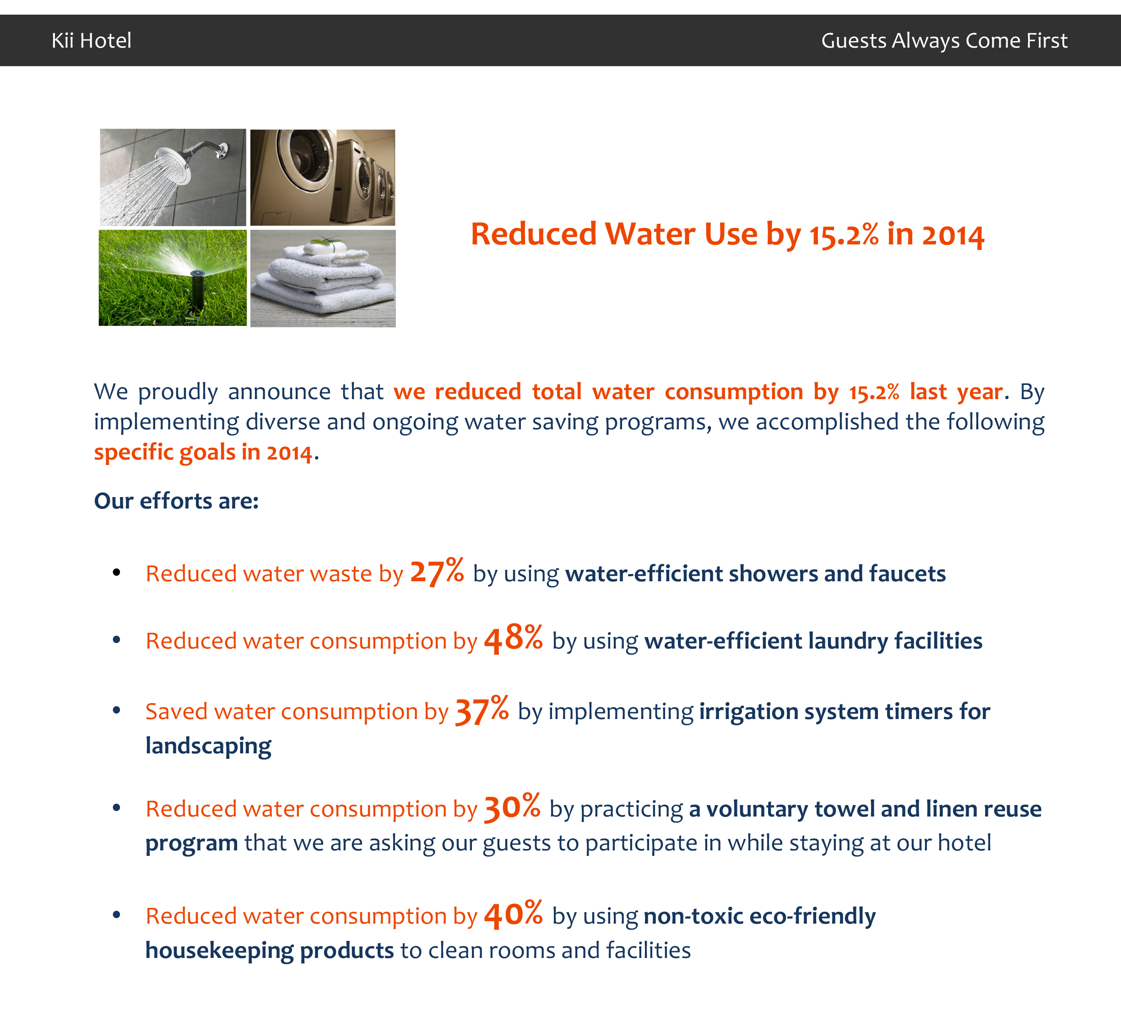
(1) An objective and impact-focused message

(2) A subjective and commitment-focused message
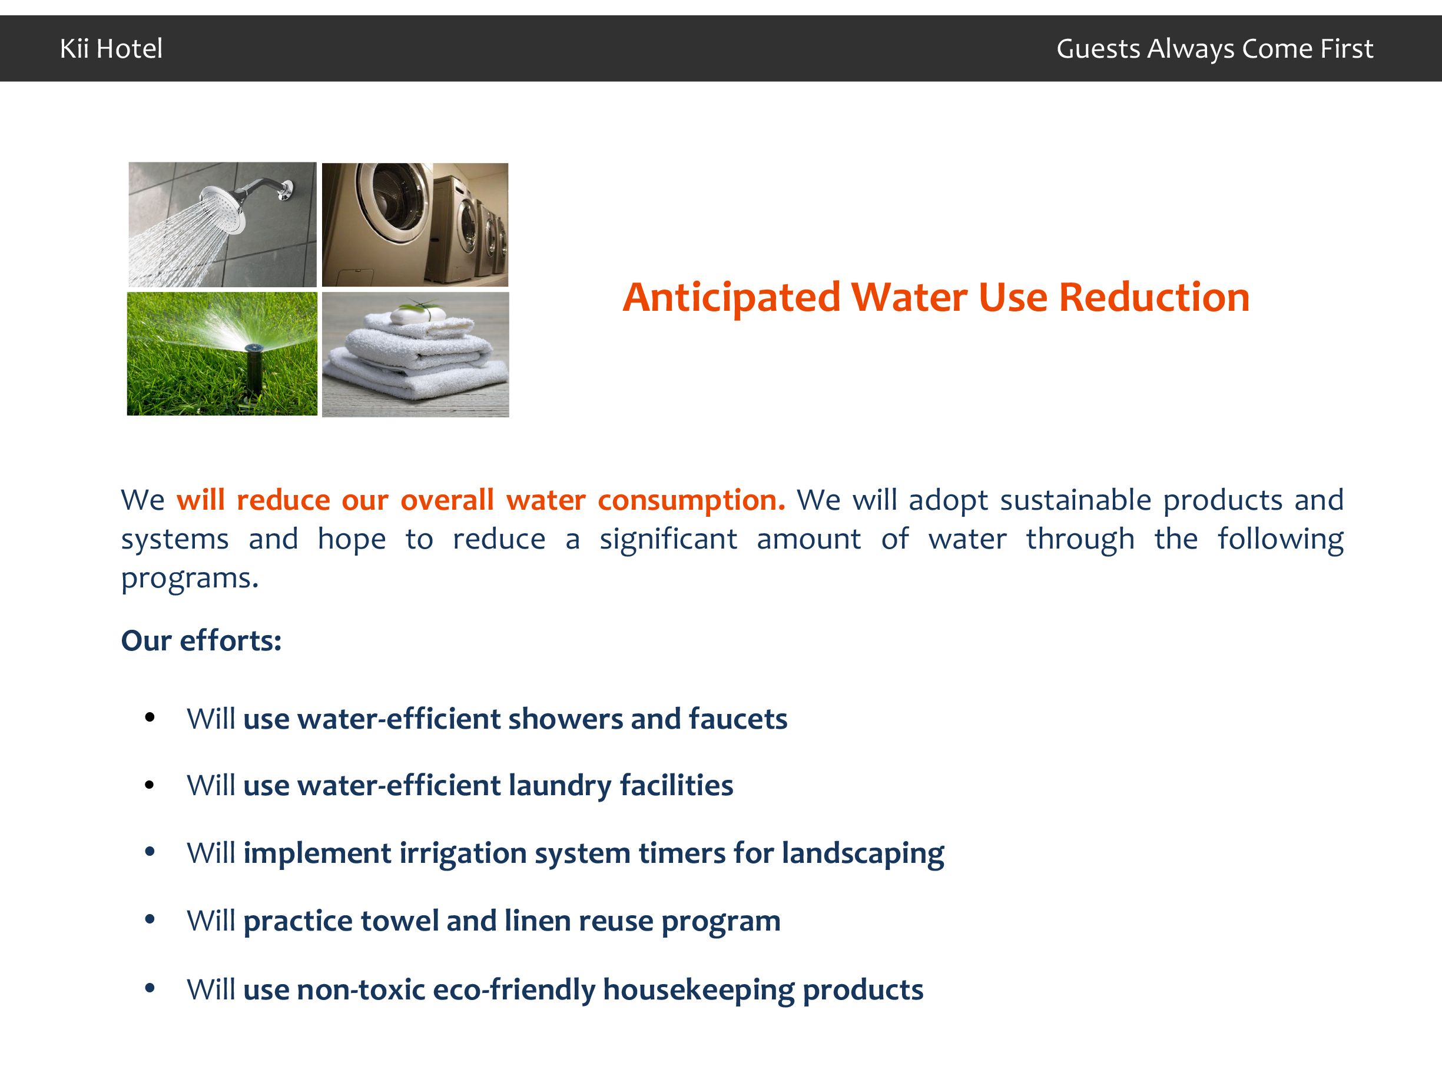

http://www.statista.com/statistics/245841/total-revenue-of-the-us-hotel-industry/

